**“HE WHO LIVES WITHOUT DISCIPLINE DIES WITHOUT HONOUR!”** - Shikhar Mittal, BVCOE

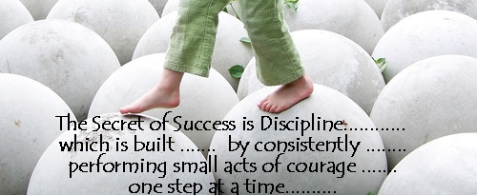 *Our life is about goals. Rarely does a person live without an ultimate aim or a dream bird fluttering somewhere over a horizon. But reaching this goal implies performing thousands of petty tasks, everyday chores, meetings and actions. Planning these activities effectively is what time management is about*.

As students, we are not the best people for managing things. We, like any other person, are confused and not very confident in taking decisions and this is the place where adults and teachers play a significant part in teaching us the role of management and boosting our morale.

Management means getting things done with the active co-operation of others. Besides, management is a goal-directed activity and is concerned with the co-ordination of work of different groups. It’s also an economic activity and involves creative thinking.

Management also involves time management which needs careful analysis on how you currently spend every minute of your day and then determining ways in which you can make better use of those minutes. This often includes eliminating many or all of the time wasters that each of us must contend with on a daily basis. It also involves learning to set priorities and better focus on tasks and obligations at hand, while not getting bogged down with irrelevant details or trying to take on too much as once.

One of the biggest reasons why people never achieve their goals and never seem to have time in their day to accomplish what they need or want to do is because of lack of organization. In your life, you can physically organize your workspace (your college work, desk, file cabinets, paperwork, and electronic files.) and your home to provide a more relaxed and productive environment. You can also organize how you spend your time.

Coming down to discipline, remember during our school assembly when we had to go through an inspection which included checking of our uniform, nails and hair? We didn’t like it but it was a part of our discipline training. Discipline is training which develops one’s moral character and helps to produce a particular type of behaviour. Training which helps the individual to correct, improve the overall conditions, moral character with the change in behavioural pattern of the individual. Discipline is an essential part of our life. In fact without discipline in life, we cannot work smoothly. Parents, elders of the family and the teachers are the first persons to instil a sense of discipline in children. Discipline must be learnt from the early stages of life.  Discipline ensures the smooth flow of life without putting hindrance to the individual's liberty. Discipline teaches us to be systematic towards achieving our goal of life. It helps us to achieve our ambitions.

Discipline is necessary both for the teacher and the students. A teacher is the leader of his charges; he must possess and main­tain an intellectual and moral discipline of a high order. However learned and scholarly a teacher may be, but if in his personal life he leads an undisciplined life, he will never be able to win and com­mand the respect and obedience of students. Similarly, only a dedi­cated and disciplined student can carry out a brilliant career for himself and serve the motherland. Dis­ciplined students are the pillars of a nation's strength and with their strength of character they can lift a nation to the great heights of progress.

We should remember— "*He alone can command who knows how to obey*".

(Icon)

